United Slovak Societies of the American Slovak Club, Lorain, Ohio

Scholarship Application Rules

- The scholarship will be a one- time, $1,000.00, non-renewable award for each qualifying applicant.

- A qualifying applicant includes a high school senior who will enter college and is a member of one or more of our five local lodges.

- An applicant must be a member of one of the five lodges that comprise the American Slovak Club in Lorain, for at least the past five (5) years. The Lodges include the following;

St. John the Baptist Lodge, FCSU, Branch #228
St. Mary Magdalene, LPSCU, Branch #77
St. Ann’s Lodge, FCSLA, Branch #114
Slovak Catholic Sokol Wreath 111 & #177
National Slovak Society, Assembly #160

- An applicant must have a minimum grade point average of 3.5 out of 4.0 for consideration.
A certified copy of your transcript must be attached.

- Please include a recent photo of yourself with the application.

- Applications must be received at the American Slovak Club by May 30th of each applicable year.
Mail completed application to:

American Slovak Club
Attn: Scholarship Coordinator
2915 Broadway Avenue
Lorain, Ohio 44055

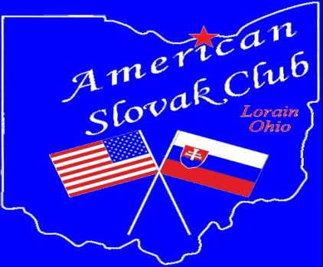
United Slovak Societies Scholarship Application
Part 1: To be filled out by student applying for scholarship

Name________________________________________________
Address______________________________________________
City, State___________________________Phone____________
Parents Name (include mother’s maiden)____________________
____________________________________________________
Slovak Lodge Affiliation_________________________________
College Attending______________________________________
Field of Study/Major_____________________________________

Part 2: On separate sheet of paper

Please write a brief essay telling how you will preserve your Slovak heritage both at home and in your community.

